# Importing OSBIDE Surveys from Excel to OSBIDE Database

## Through OSBIDE Admin User Interface

* Note #1: Please check OSBIDE database and make sure [dbo].[OsbideSurveys] and [dbo].[StudentGrades] tables exist and the schemas match what’s in the spreadsheet. Run CreateImportTables.sql scripts to create [dbo].[OsbideSurveys] and [dbo].[StudentGrades] tables if they are not already in OSBIDE database.
* Note #2: Since the work is done on Azure platform, Excel data needs to be saved in xlsx format, not in xls format (32 bit).

1. Login OSBIDE web application with Admin role.
2. Go to “ADMIN” view.

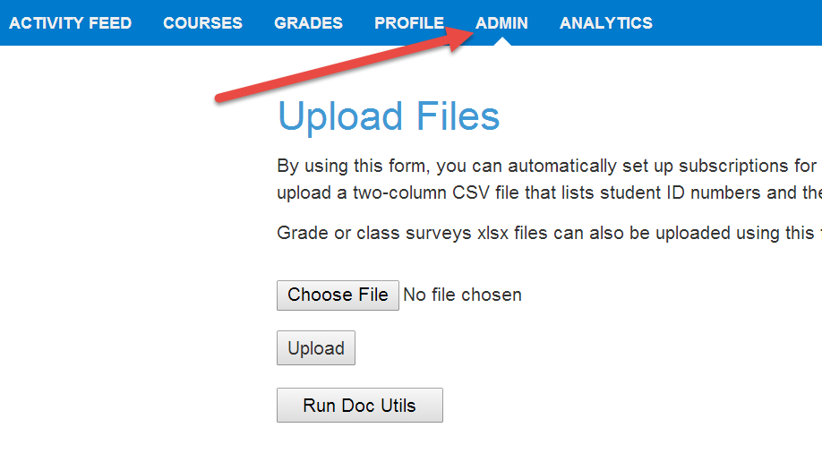

1. Choose an xlxs file that matches survey or grade schema in OSBIDE database.

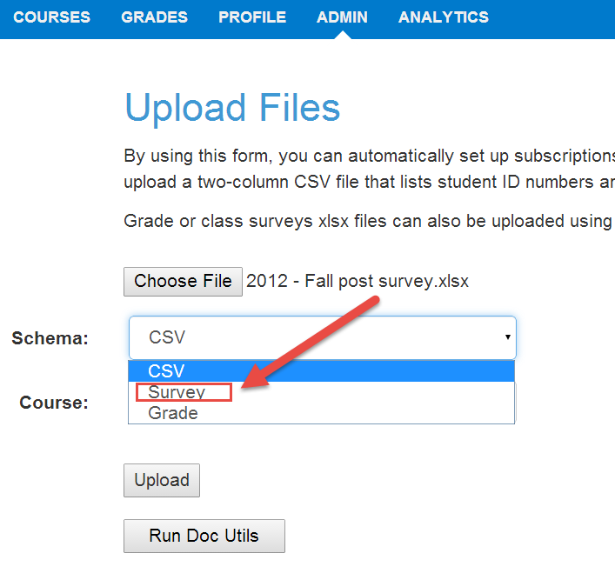

1. Choose Course [and Deliverable for grades]. The courses and deliverables in the dropdowns are populated by the data in [dbo].[Courses] and [dbo].[assignments] tables. In order to upload and later to retrieve the data, courses and deliverables need to exist in the database.

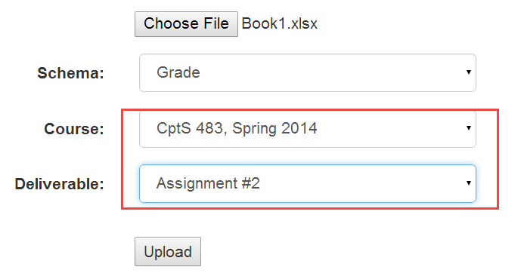

1. Click “Upload”

If upload succeeded, a success message will be shown on the page.

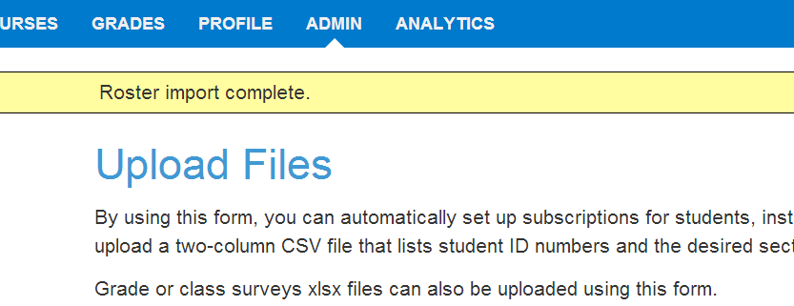

Otherwise a detailed error message will show to the user.

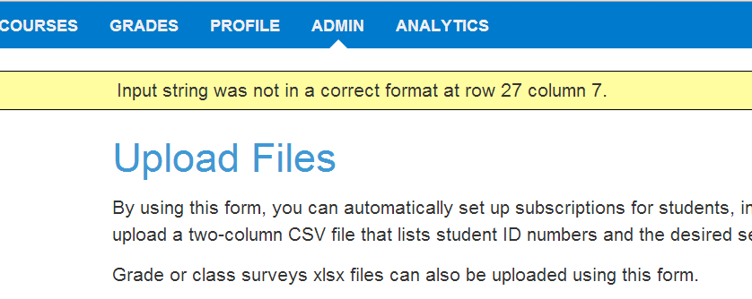

# Through SQL Server Data Tool in Management Studio

1. Connect to OSBIDE database in SQL Server Management Studio
2. In Object Explore, select OSBIDE database
3. Use context menu to select ***Tasks/Import Data***. This will launch SQL Server Import and Export Wizard. Click on ***Next***.

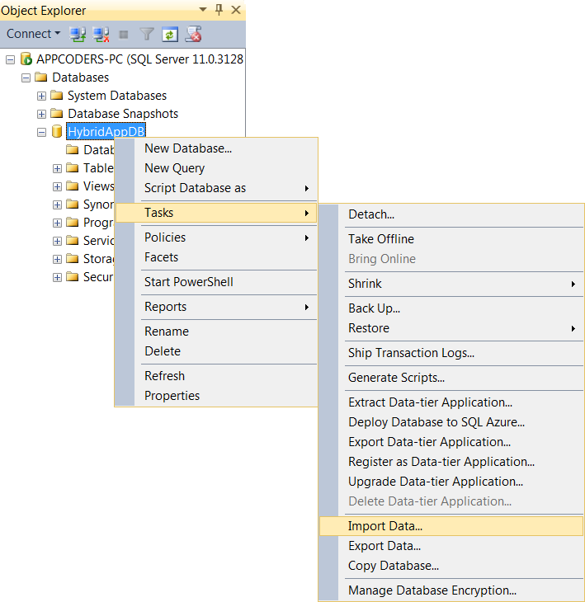 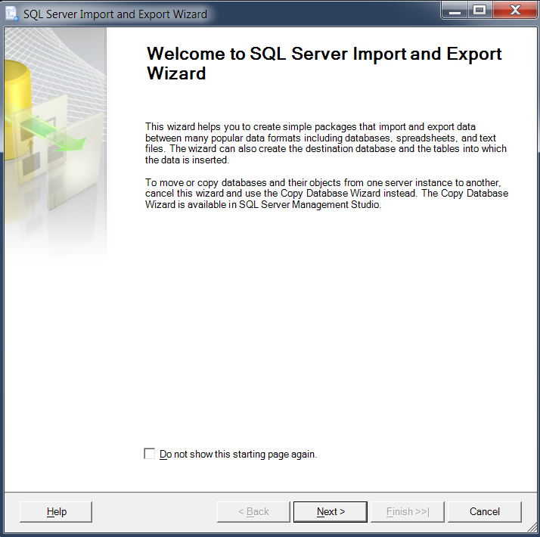

1. Select ***Microsoft Excel*** as the import data source and provide the Excel file path. Check “First row has column names” if the first row of the Excel file includes column names. Click on ***Next***.

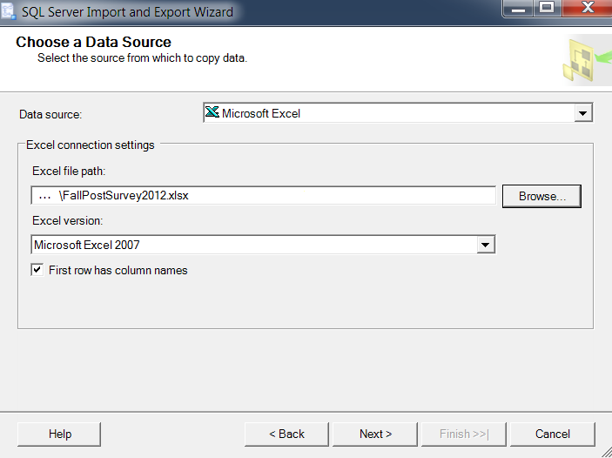

1. Select the destination database (***OSBIDE***) and click on ***Next***.

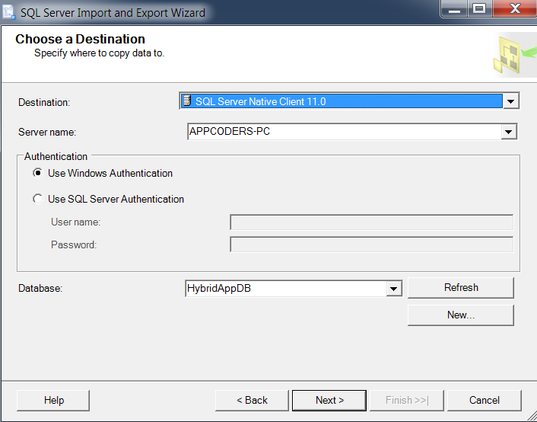

1. Specify “Copy data from one or more tables or views” and click on ***Next***.

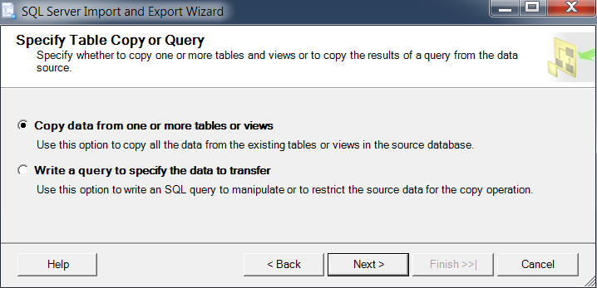

1. Rename the destination table name to ***OsbideSurveys*** and click on ***Edit Mappings*** to launch columns mapping view.
   1. If the table doesn’t exist in the database, the “Create destination table” radio button is checked. The column schema should be modified in either the data grid or the “Create Table SQL Statement” popup. ***\*Need to***
      1. add ***OsbideSurveyId*** identity column
      2. change all ***float*** data type columns to use ***int*** type
      3. remove white spaces in column name strings

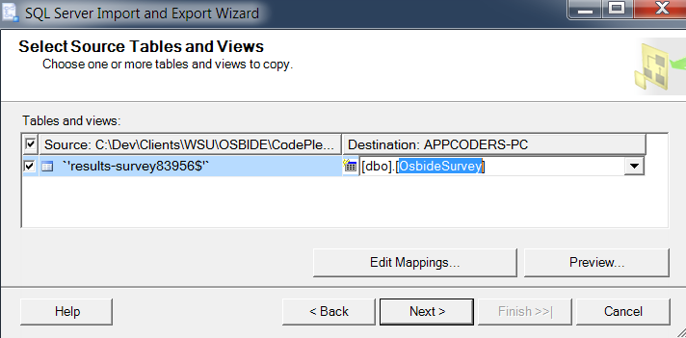

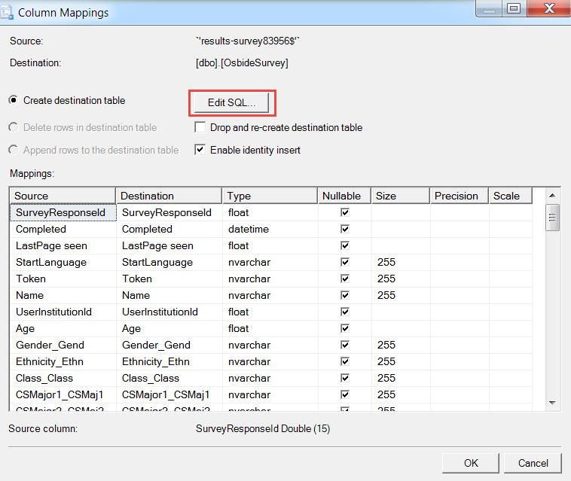

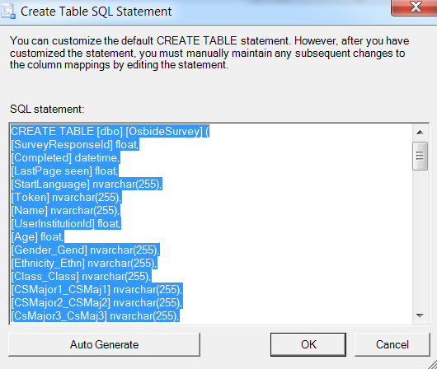

1. Click ***OK/OK*** and ***Next*** in step #7.